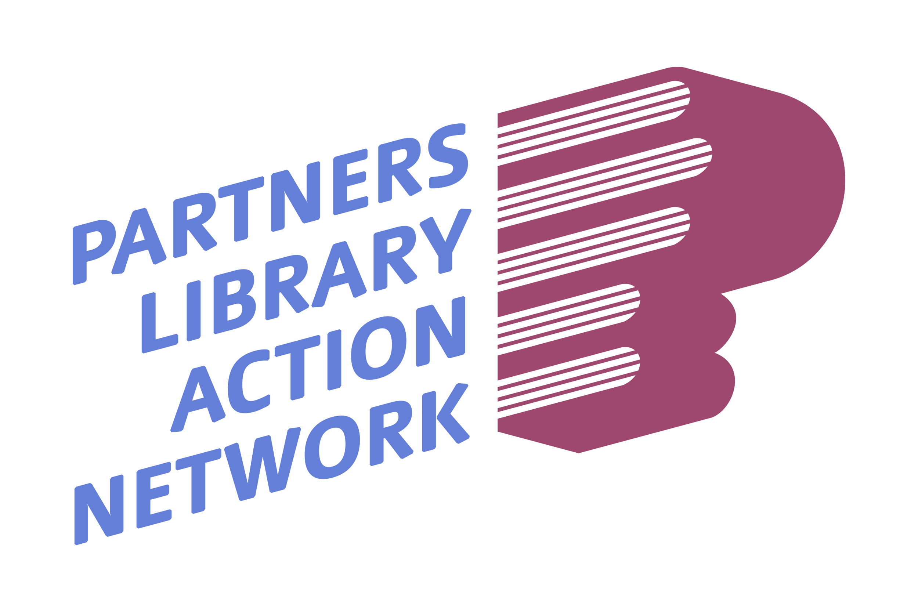

OCTOBER 11, 2024 AGENDA

INVITATION FOR ALL PLAN MEMBERS to ANNUAL MEMBERSHIP MEETING!

We are incredibly excited to be able to offer you a wonderful experience at PLAN Annual Membership Meeting this year. Our Keynote Speaker, Edward Melton, Harris County Executive Director will be discussing his vision of how Empathy in Action helped engineer his team to national success in garnering the National Merit Award from IMLS. This is a day you won’t want to miss!

Please join us virtually from Larry J Ringer Public LIbrary

ACCESS THE LINK: [VIRTUAL MEETING LINK](https://meet.google.com/ewq-hnfb-pna)